AI ASSISSTANT CODING LAB-11.4
Name: D. Venu madhav
Batch:42
Rollno:2303a52284
Task 1: Stack for Undo Operations (LIFO)
Prompt Used
Design a Python class that models an Undo feature for a simple text editor using the Stack data structure. The class should include methods to add a new action, remove the latest action, view the most recent action without deleting it, and check whether any actions exist. Provide meaningful docstrings, demonstrate its use with test cases, justify why the stack structure is appropriate for undo systems, and discuss the differences between implementing the stack using a Python list and using the collections.deque module. Code
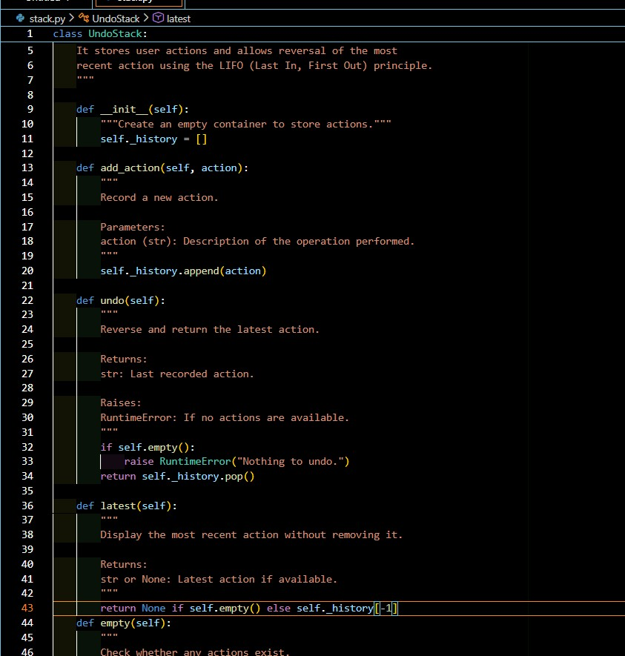

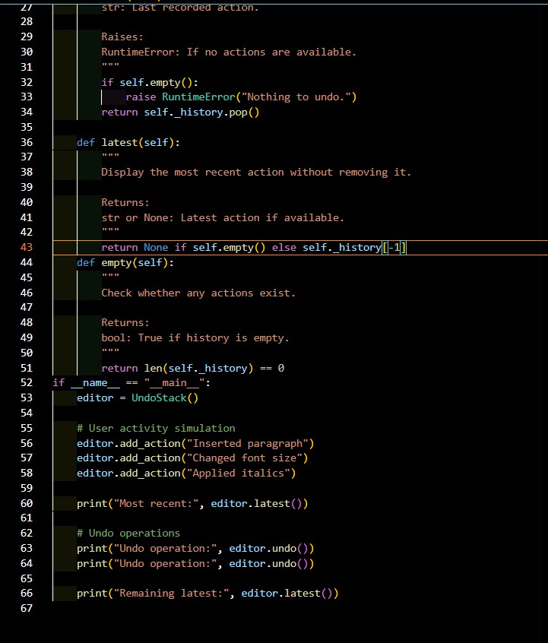
Optimized

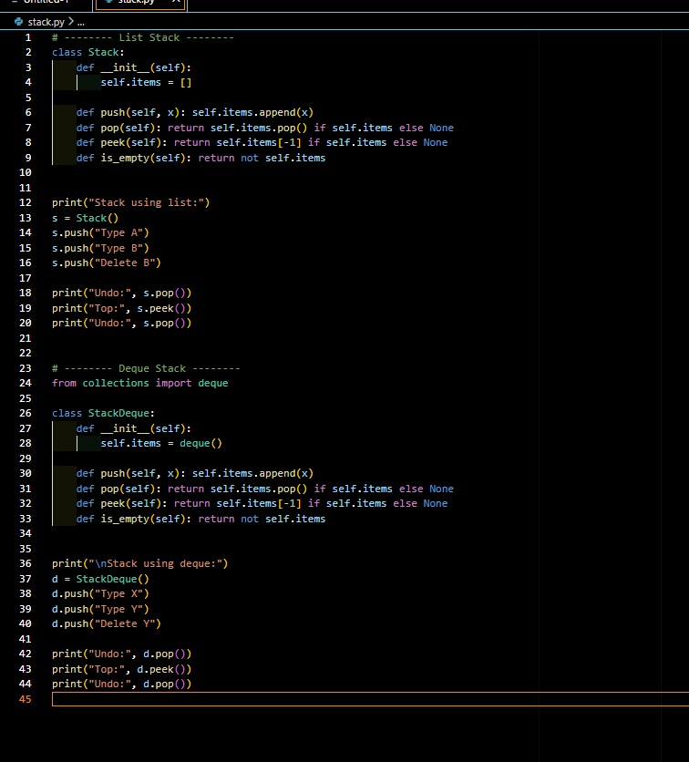
Output:
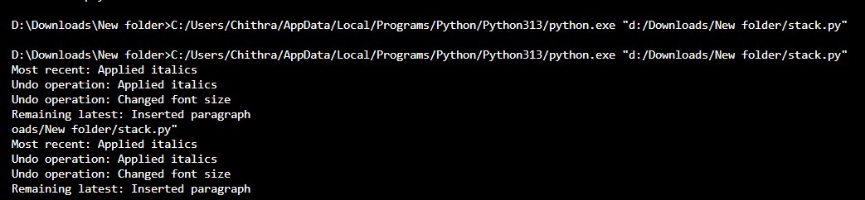
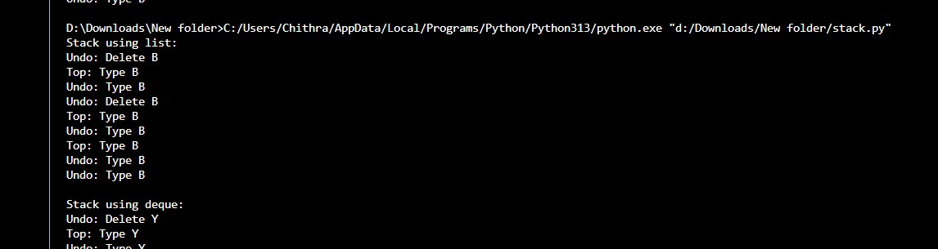

Justification
Why Stack is Suitable for Undo
Undo operations must reverse the most recent action first. This matches LIFO behavior:
- Latest action → undone first
- Earlier actions → undone later Example:
- Type A
- Type B
- Delete B
Undo → Delete B undone first
Stack provides O(1) push and pop, making it ideal for frequent undo operations.
Task 2: Queue for Customer Service (FIFO)
Prompt Used
Design a customer support system in Python where service requests are handled in the order they arrive. Implement a Queue class with methods to add a request, process the next request, and check whether the queue is empty. First use a list-based approach. Then analyze its performance, suggest an optimized version using collections.deque, and explain why the deque structure is more efficient in real-world applications.

Code:
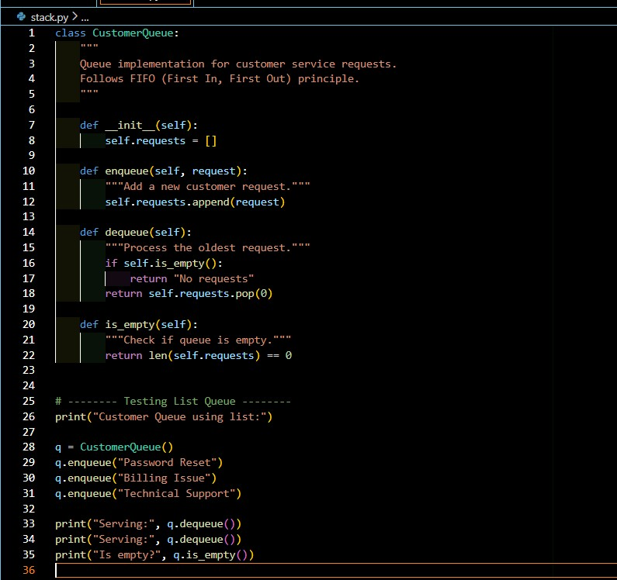

Optimized
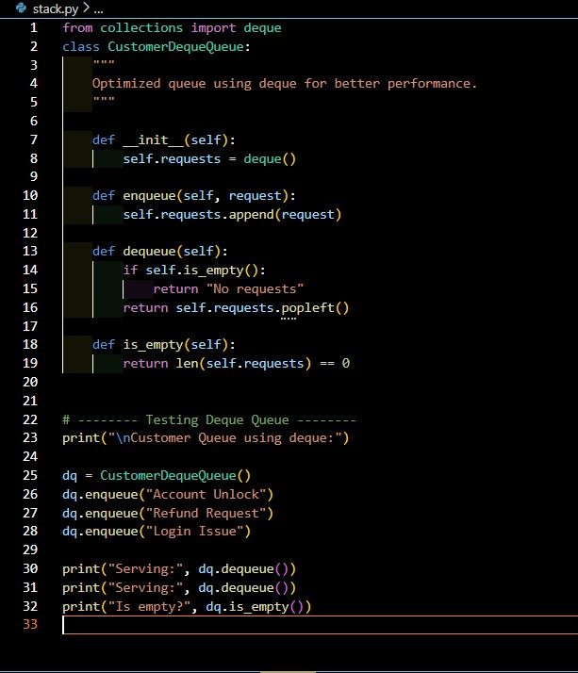

Output:

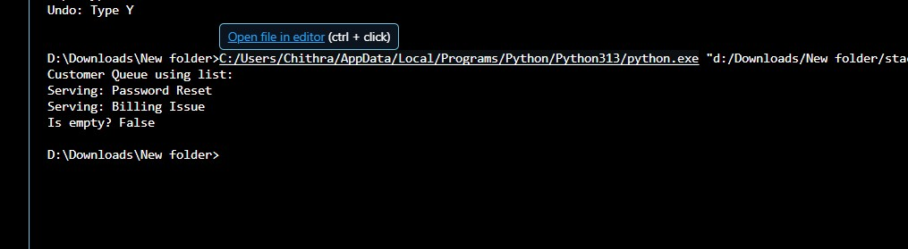

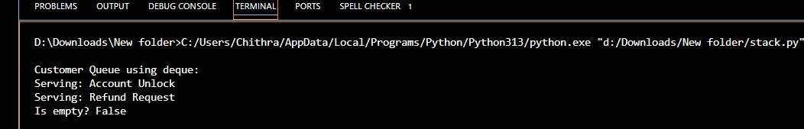

Performance Analysis
List-Based Queue
- enqueue → O(1)
- dequeue → O(n) (shifts elements)
For 10,000 requests, dequeue becomes expensive.
Deque-Based Queue
- enqueue → O(1)
- dequeue → O(1)
Deque uses a doubly-linked structure internally, avoiding element shifting.
Real-World Impact
In high-volume systems (banking, server queues, chat systems), list-based queues degrade performance significantly. Deque ensures stable O(1) operations.
Task 3: Singly Linked List for Dynamic Playlist Management
Prompt and code
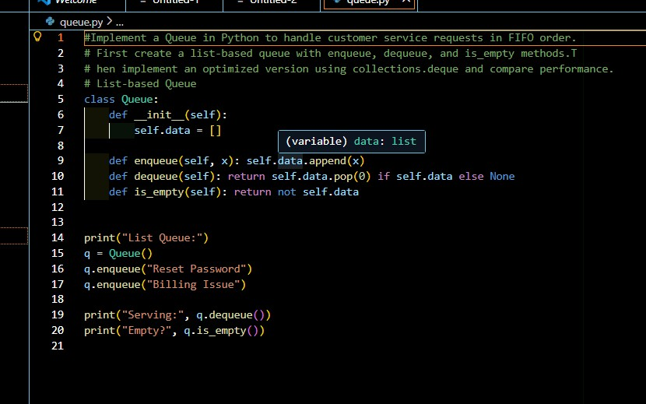

Output:

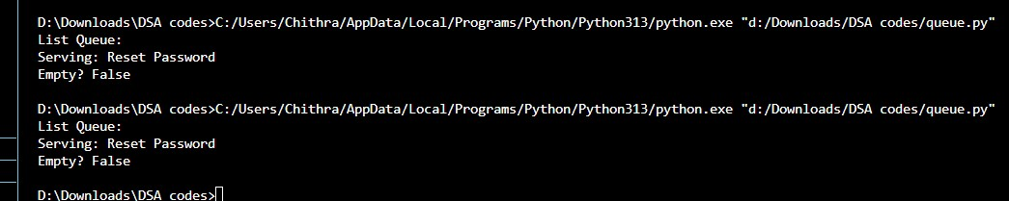

Edge Cases
- Empty list insertion
- Delete from empty list
- Delete head node
- Delete single node list
- Delete non-existent value
Task 4: Binary Search Tree for Fast Record Lookup
Scenario
You are building a student record system where quick searching by roll number is required.
Task Description
• Implement a Binary Search Tree (BST) with:
o insert(value) o search(value) o inorder_traversal()
• Provide AI with a partially written Node and BST class.
Prompt used :
Complete missing methods,Add meaningful docstrings, Explain how BST improves search efficiency over linear search
Code
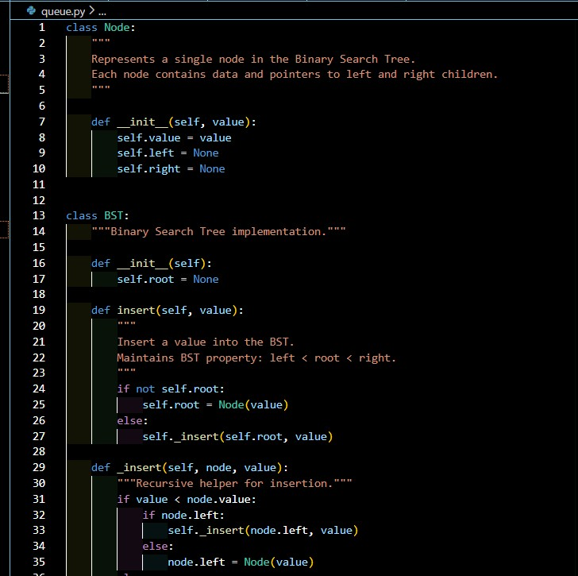
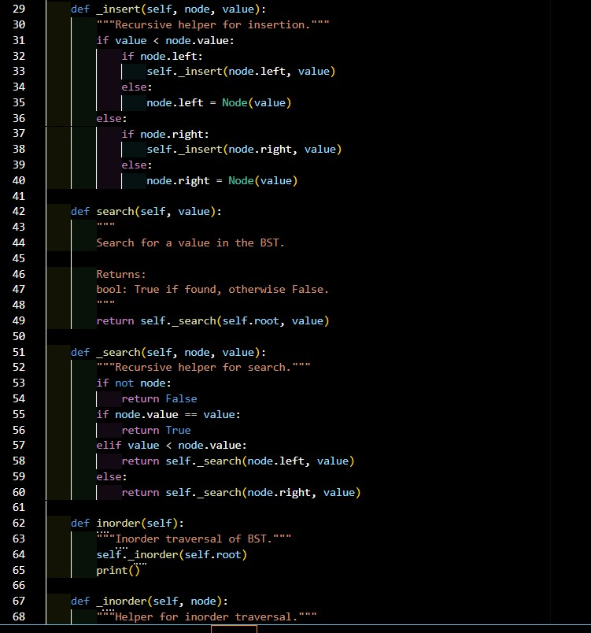

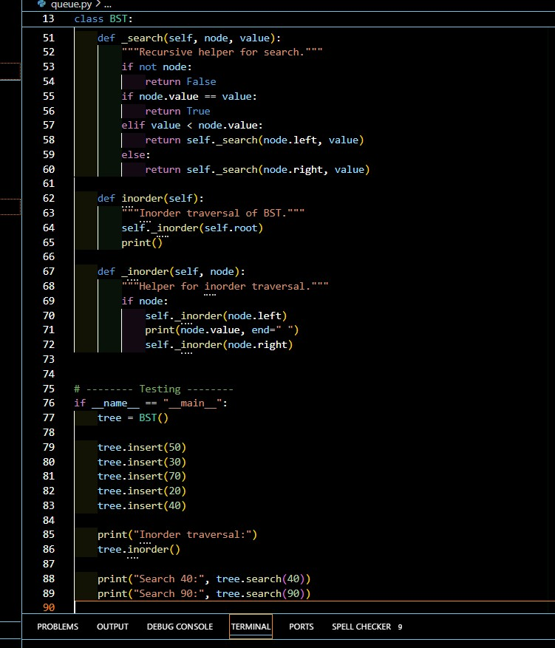

Output:
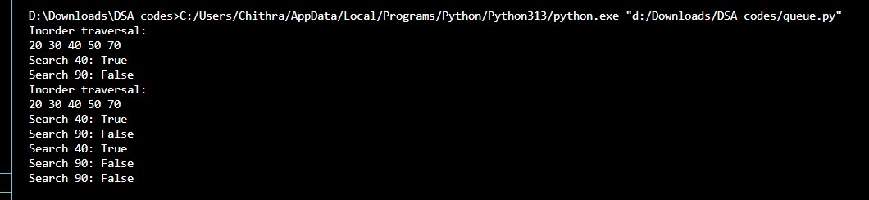

Why BST Improves Search Efficiency

Approach | Time Complexity
Linear Search | O(n)
BST (Average) | O(log n)
BST (Worst - Skewed) O(n)
BST reduces search space by half at each step in balanced cases.
Task 5:
Graph Traversal for Social Network Connections
Scenario
You are modeling a social network, where users are connected to friends, and you want to explore connections.
Task Description
Represent the network using a graph (adjacency list).
• Use AI to implement: o Breadth-First Search (BFS) to find nearby connections o Depth-First Search (DFS) to explore deep connection paths prompt used:
Add inline comments explaining traversal steps, Compare recursive and iterative DFS approaches,Suggest practical use cases for BFS vs DFS Code:
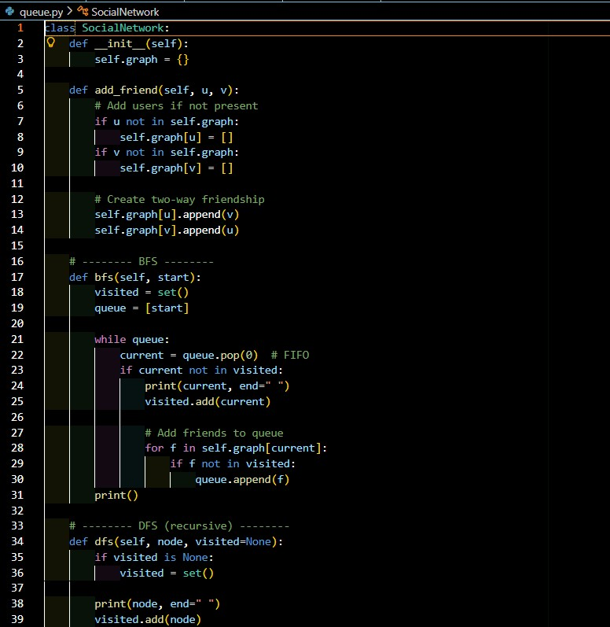
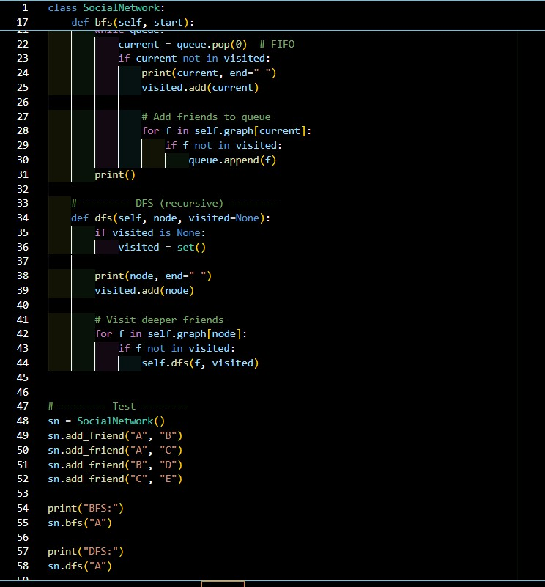
Output:
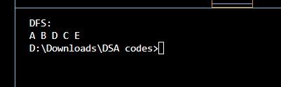

BFS vs DFS Comparison

Feature BFS DFS
Structure Queue Stack/Recursion
Traversal Level-by-level Depth-first
Shortest Path Yes (unweighted) No
Memory Higher (wide graphs) Lower (deep graphs)

